Online Chinese Character Handwriting Recognition for Linux

Author: Ran Cheng
Student ID: n5105269
Course: IT29 - Honours of IT
Primary Supervisor: Jim Hogan
Associated Supervisor: Jinhai Cai

Abstract:
Redhat Linux is one of the leading Linux distributions in the market. Redhat Linux provides user friendly

Table of Content
Abstract: 1
Chapter One: Introduction 2
1.1 Statement of Research Problem 2
1.2 Research Aim and Objects 2
1.3 Rationale/Background 2
1.4 Significance of Study 2
1.5 Limitations of Study 2
Chapter two: Background and Related work 3
2.1 Hidden Markov Model (HMM) 3
2.1.1 Introduction 3
2.1.2 Element of HMM 3
2.1.3 Three classic problems 4
2.1.4 Type of HMMs 5
2.2 Dynamic Programming (DP) 6
2.3 Viterbi Algorithm 8
2.4 Chinese Character Processing 8
2.4.1 Introduction 8
2.4.2 Character segmentation 8
2.4.3 Pre-processing 9
2.4.4 Pattern Representation 9
2.4.5 Classification 10
2.4.6 Context processing 11
2.5 Smart Common Input Method (SCIM) 11
2.6 GTK+ 11
Chapter Three: Handwriting Recognition System 12
3.1 Writing pad 12
3.1.1 Event handling 12
3.1.2 Drawing Area Widget and Drawing 14
3.1.3 GUI 15
3.2 Data collection 15
3.2.1 Data selection criteria 16
3.3 Data organization 18
3.4 Data format 20
3.4.1 Raw data file 20
3.4.2 Feature data file 21
3.4.3 Distribution probability file 22
3.4.4 Transition probability file 23
3.4.5 Result file 24
3.5 Initial raw data collecting and processing 25
3.6 Feature analysis 26
3.6.1 Character decomposition 26
3.6.2 State decomposition 27
3.7 Training state initialisation 28
3.7.1 Observation segmentation 28
3.7.2 Feature distribution 28
3.7.3 State Transition 28
3.8 Training state optimisation 28
3.8.1 Customised Viterbi algorithm 28
3.8.2 Observation segmentation 28
3.8.3 Feature distribution 28
3.8.4 State Transition 29
3.9 Character recognition 29
Chapter Four: Experiment and Results 29
4.1 Data Sets Selection 29
4.2 Evaluation Criteria 29
4.3 Scalability (cover the extend data sets) 29
4.4 Result Evaluation 29
Chapter Five: Conclusion and Future work 29
5.1 Findings and Analysis 29
5.2 Improvements 29
5.2.1 Writing Pad XInput support 29
References 29

Table of Feature
Figure 1 Chinse character stroke list (Education) 17
Figure 2 Data collection 18
Figure 3 Data framework 20
Figure 4 Raw data text file 21
Figure 5 Feature data file 22
Figure 6 part of a transition probability file 24
Figure 7 Result file 25

Chapter One: Introduction

Statement of Research Problem

Research Aim and Objects

Rationale/Background

Significance of Study

Limitations of Study

Chapter two: Background and Related work

Hidden Markov Model (HMM)

Introduction
HMM was initially introduced and studied in the late 1960s and early 1970s, and it’s kind of statistical methods of Markov Source. HMM is assumed to be a Markov process with unknown parameters, and the challenge is to determine the midden parameters from the observable parameters. The extracted model parameters can be used to perform further analysis, and one example is the pattern recognition application which is category our project belongs to. HMM differs from Markov model, because in Markov model, the state is directly visible to the observer, in the HMM, the state is hidden but the state can influence some variables which are visible. Each state has a probability distribution over the possible output observations, so the sequence of observations generated by an HMM gives some information about the sequence of states.(Wikipedia, 2006b) In our project, for the handwriting part, the stokes can be transformed into a sequence of dots, which can be treated as the observation sequence, and the final shape of the character can be treated as the state. Therefore, by observing the sequence of dots input by user, the system will guess the correct character. This is one of the main reasons we choose HMM, and the other two strong reasons the HMM draw our attention are: firstly, the models are very rich in mathematical structure and hence can from the theoretical basis for use in a wide range of applications; secondly, when the models are applied properly, it works well in practice for several important applications. (Rabiner, 1989)

Element of HMM
An HMM is characterized by the following:
1) N, the number of states in the model. As we mentioned in the introduction, the state is hidden in the models, but for many practical applications, the number of the state are known.
2) M, the number of distinct observation symbols per state.
3) The state transition probability distribution A = {aij}, where
The formula means the probability of changing state from Si at time i to Sj at time j.
4) The observation symbol probability distribution in state j, B={bj(k)}
5) The initial state distribution π.

Given appropriate values of N, M, A, B and π, the HMM can be used as a generator to give an observation sequence.

HMM is very large math model, and it can be used in a lot of areas by selecting proper elements and use it in different way. In the other word, not all the elements will be used for every scenario. Generally, when some elements are not used, we sign a default value to them.

Three classic problems
Problem 1: Given the observation sequence and a model, how to efficiently compute the probability of the observation sequence, given the model?
Problem 2: Give the observation sequence and the model, how to choose a corresponding state sequence whch is optimal in some meaningful sense?
Problem 3: How to adjust the model parameters to maximize the probability of the observation sequence.

We don’t want to worry about how to get the solution to those problems; instead of we want to discuss the implication of the problem and how we can use those solutions to resolve problems.

Problem 1 is the evaluation problem. This problem can be treated as one of scoring how well a given model matches a given observation sequence. In other words, problem 1 allows us to choose the model which best matches the observations.

Problem 2 is trying to uncover the hidden part of the model – state. One thing we should pay attention is that we can’t really find the “correct” state sequence. All we can do is to find out the best or optimal state sequence. Normally, there are several reasonable optimality criteria that can be imposed, and hence the choice of criterion is a strong function of the intended use for the uncovered state sequence. For our project, we’ll be using the theory listed in this problem. By observing the observation sequence, the system will try to find out all the possible states (characters) and list the top 10 or whatever number we required.

Problem 3 can be viewed as a “training” problem. The observation sequence used to adjust the model parameter is called a training sequence since it is used to “train” the HMM. The training process will be essential part of our project. For our project, after developing the recognition system, we need train it, and we need let it be able to recognize the template for each character.

Type of HMMs
There are two main types of HMMs and there are many possible variation and combinations possible. The first main type of HMM is called ergodic model, in which every state can be reached from ever other state in a finite number of steps. This kind of HMM is most common used in the practice. The seconde main type of HMM is called left-right model or a Bakis model. In this kind of model, the state sequence has the property that as time increases the state index increases. We use the following two pictures to show the underlying structure of these two models.
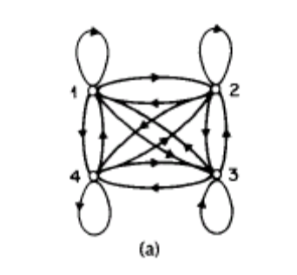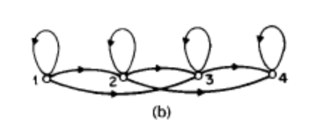
We can see from pic (a), all the states are connected with each other, and the arrows indicate the communication directions are enabled. In pic (b), at any time, the current state can only communicate with the following states and itself, but no previous state can be reached.

Ergodic model seems to be better than left-right model, since every state can be reached from every other state in a finite number of steps. But in the world, left-right model is more useful because it is easier and most of the applications do not need change the state back to previous one.

The left-right model are particular useful for our project, because this kind of model has “the desirable property that it can readily model signals whose properties change over time”(Rabiner, 1989), like speech and handwriting.

Dynamic Programming (DP)
“In computer science, dynamic programming is a method for reducing the runtime of algorithms exhibiting the properties of overlapping subproblems and optimal substructure, described below.”(Wikipedia, 2006)

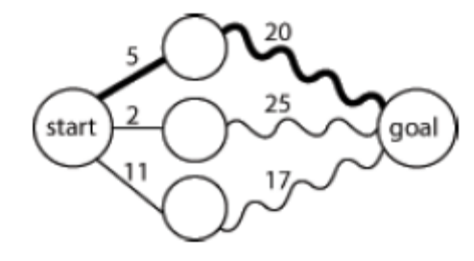
Optimal substructure means that optimal solutions of subproblems can be used to find the optimal solutions of the overall problem. We use the picture shown left to explain the definition. Starting from the leftmost circle, we got three paths to reach the rightmost circle. The number between near the line means the distances. By observing the picture, we can see at the middle of the overall path, the second path from the top has the shortest distance, however, in terms of the total distance, the top path is the shortest. Although the second path was leading the way at some point, the optimal solution is the top path.

Normally, three-step process we should take is:
Firstly, break the problem into smaller subproblems.
Secondly, solve these problems optimally using this three-step process recursively.
Thirdly, use these optimal solutions to construct an optimal solution for the original problem.(Wikipedia, 2006)

Overlapping subproblems mean that the same subproblems are used to solve many different larger problems. We take Fibonacci sequence as example, F3 = F1 + F2 and F4 = F3 + F2, the consequence calculation also include F2. The calculation of F2 is involved in each following calculations. So we say F2 is the overlapping subproblem in Fibonacci sequence.

The overlapping subproblem introduced a new problem to us. In each calculation of Fibonacci sequence, the calculation may end up computing F2 twice or more. In this approach, it may waste time recomputing optimal solutions to subproblems the system has already solved. To avoid this, the memoization approach was introduced. Memoization means that if the same problem may be need to resolve later, the system will save the solutions to the problem and retrieve and reuse the solutions.

DP usually takes one of two approaches:
Top-down approach: break the problem into subproblems, and after resolve these subproblems, recombine all the subproblems back together.
Bottom-up approach: resolve all the subproblems in advance and then use them to build up solutions to larger problems.

DP can be very useful in the character recognition processing. Picture shown below simulate DP in Chinese Character recognition. As the new strokes are added in, the possibilities of the character change over time, eventually, the system will optimize all the possible solutions and find the best fit one.
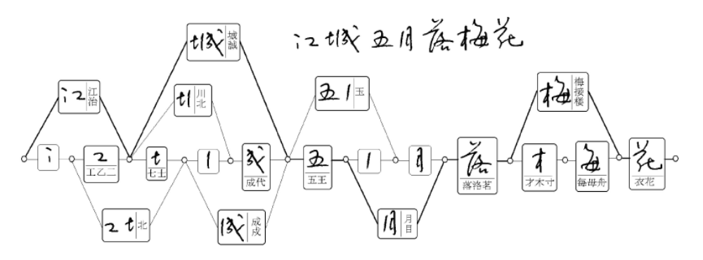

Viterbi Algorithm

Chinese Character Processing

Introduction
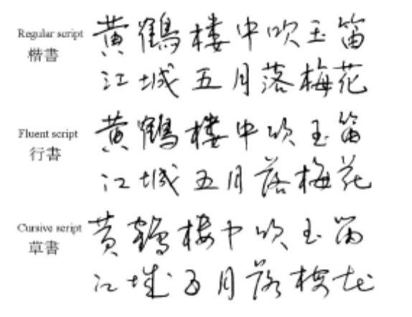
More than one quarter of world’s population use Chinese characters in daily communications. There are three main types of Chinese characters: simplified Chinese characters, which are used in mainland China and Singapore; traditional Chinese characters, which are used in Taiwan, Hong Kong and Macao; and Japanese Kanji, which are used in Japan. In both traditional and simplified Chinese, about 5,000 characters are frequently used, In Kanji, 2,965 Kanji characters are included in the JIS level 1 and 3,390 characters in level 2.(Liu, Jaeger, & Nakagawa, 2004) Although there are a lot of styles of Chinese Characters, normally, the most common used three styles are regular script, fluent script and cursive script. Picture on the right-hand side show the difference between these styles.

Character segmentation
When the handwriting sequence is input into the system, no matter what kind of types of Chinese characters or styles they are, the sequence should be segmented into character patterns according to the temporal and shape information. Frequently, the boundary between characters can’t be determined unambiguously before character recognition, so a set of candidate character patterns are selected in contextual processing at the end of the process chain. After the segmentation, a set of individual Chinese character are output to next stage. Although there is a lot of research work has been done separately, a lot of recognition approaches are available, but for the segmentation part, almost all researchers follow the same pattern.

Pre-processing
Pre-processing consists of noise elimination, data reduction, and shape normalizations. The common used noise reduction techniques are smoothing, filtering, wild point correction, stroke connection, etc.(Tappert, Suen, & Wakahara, 1990) As the quality of input devices is getting mutual and better, trajectory noise becomes less influential and simple smoothing operations will suffice.(Liu et al., 2004)

Two frequently used approaches for data reduction are equidistance sampling and line approximation. With equidistance sampling, the trajectory points are resampled such that the distance between adjacent points is approximately equal. Line approximation, also called feature point detection, is often used in many online recognition systems.

Normalization of character trajectories to a standard size is adopted in almost every recognition system, so will our project. Three main approaches for normalization are linear, moment and nonlinear normalization. Linear normalization means that the coordinates of stroke points are shifted and scaled such that all points are enclosed in a standard box. Moment normalization means that the centroid of input pattern is shifted to the centre of standard box and the second-order moments are scaled to a standard value.(R.G.Casey, 1970) Nonlinear normalization means that the coordinates of stroke points according to the line density distribution with the aim of equalizing the stroke spacing.(S.-W., Lee, & Park, 1994)

Pattern Representation
The representation schemes of input pattern and model database are of particular importance since the classification method depends largely on them. The representation schema can be divided into three groups: statistical, structural, and hybrid statistical structural. In statistical representation, the input pattern is described by a feature vector, while the model database contains the classification parameters. The statistical-structural scheme is only used for describing he reference models. It takes the same structure as the traditional structural representation, yet the structure elements and/or relationships are measured probabilistically. HMM can be regarded as instances of the statistical-structure representation.

Pattern Representation and the following section – Classification will be the main area we are going to focus on in our project. We’ll be trying to apply HMM to the new algorithm.

Classification
Classification is the core of almost every recognition system. Classification can be further divided into coarse classification and fine classification. Coarse classification can be accomplished by class set partitioning or dynamic candidate selection. In class set partitioning, the groups of classes are determined in the classifier design stage using clustering or prior knowledge. Class grouping can be based on overall character(C. K. Lin & Fan, 1994), basic stroke substructure(R. H. Chen, Lee, & Chen, 1994), stroke sequence(Z. Chen, Lee, & Cheng, 1996), and statistical or neural classification(Matic, Platt, & Wang, 2002). In dynamic candidate selection, a matching score is computed between the input pattern and each class and a subset of classes with high scores is selected for details classification.

In fine classification, three common used approaches are Structural Matching, Probabilistic Matching and Statistical Classification. Structural matching means the input pattern is matched with the structural model of each (candidate) class and the class with the minimum matching distance is taken as the recognition result. Probabilistic matching means that using probabilistic attributes in representing structural models and computing matching distance. Statistical classification means that using various statistical techniques for classification when describing the input pattern as a feature vector.(Liu et al., 2004)

Context processing
The linguistic context can provide valuable information for selecting the optimal class from this set of candidates. In addition, the geometric features of character patterns are useful to segment a handwriting sequence into single characters. Based on the candidate classes given by the character recognizer, additional candidates can be added according to the statistics of confusion between characters in order to reduce the risk of excluding the true class. The selection of final class from candidate class is based on the linguistic knowledge represented in word dictionaries, character-based n-grams, or word-based n-grams.(M.-Y. Lin & W.-H.Tsai, 1988) .Some locale specific dictionary can be used to help to determine the optimal solutions. The ambiguities in segmentation are generally solved by generating candidate character patterns and verifying the candidate patterns using geometric features, recognition results, and linguistic knowledge.

Smart Common Input Method (SCIM)

GTK+
GTK+ is a multi-platform toolkit for creating graphical user interfaces. Offering a complete set of widgets, GTK+ is suitable for projects ranging from small one-off projects to complete application suites.

GTK+ is free software and part of the GNU Project. However, the licensing terms for GTK+, the GNU LGPL, allow it to be used by all developers, including those developing proprietary software, without any license fees or royalties.
GTK+ is based on three libraries developed by the GTK+ team:
GLib is the low-level core library that forms the basis of GTK+ and GNOME. It provides data structure handling for C, portability wrappers, and interfaces for such runtime functionality as an event loop, threads, dynamic loading, and an object system.
Pango is a library for layout and rendering of text, with an emphasis on internationalization. It forms the core of text and font handling for GTK+-2.0.
The ATK library provides a set of interfaces for accessibility. By supporting the ATK interfaces, an application or toolkit can be used with such tools as screen readers, magnifiers, and alternative input devices.
GTK+ has been designed from the ground up to support a range of languages, not only C/C++. Using GTK+ from languages such as Perl and Python (especially in combination with the Glade GUI builder) provides an effective method of rapid application development. (team, 2006)
Basically, GTK+ is like Swing in Java, and just more complicated, since GTK+ can be used to develop the GUI for entire Operating System. In terms of using GTK+ in our project, that’s low level or programming level stuff, it’s not really possible to explain more without showing the code.

Chapter Three: Handwriting Recognition System

Writing pad
To recognize the Chinese character, we need some mechanism in place to take users’ input. A writing pad is most common used mechanism to make the users’ input happen. Under Linux, GTK+ is handy a multi-platform toolkit for creating graphical user interfaces. Besides creating a handwriting pad, GTK+ can be extended to support for XInput devices, such as drawing tablets. Furthermore, GTK+ provides support routines which make getting extended information, such as pressure and tilt, from such devices quite easy. In this project, we’ll be using GTK+ to create the writing pad only, the further support can be added in the future work. In terms of writing pad, there are three things we need to cope with: Event handling, Drawing Area Widget and Drawing.

Event handling
Before I explain the writing pad event handling, I’ll give a brief explanation about theory of signals and callbacks in GTK+. GTK is an event driven toolkit, which means it will sleep the main controller event until an event occurs and control is passed to the appropriate function. This passing of control is done using the idea of "signals". (Note that these signals are not the same as the Unix system signals, and are not implemented using them, although the terminology is almost identical.) When an event occurs, such as the press of a mouse button, the appropriate signal will be "emitted" by the widget that was pressed. This is how GTK does most of its useful work. There are signals that all widgets inherit, such as "destroy", and there are signals that are widget specific, such as "toggled" on a toggle button. Callback is relative easier theory to understand. Callback is just like method or function in a programming language.

Mouse moving and key pressing are low-level GTK+ events. The corresponding low-level signals and event handlers which have an extra parameter that is a pointer to a structure containing information about the event are required to handle these kinds of events. For example, motion event handlers are passed a pointer to a GdkEventMotion structure which looks (in part) like:
struct _GdkEventMotion
{
GdkEventType type;
GdkWindow *window;
guint32 time;
gdouble x;
gdouble y;
...
guint state;
...
};
Where type will be set to the event type, window is the window in which the event occurred. x and y give the coordinates of the event, state specifies the modifier state when the event occurred (that is, it specifies which modifier keys and mouse buttons were pressed).

In the writing pad program, we are interested in when the mouse button is pressed and when the mouse is moved, so we specify GDK_POINTER_MOTION_MASK and GDK_BUTTON_PRESS_MASK as the GdkEventType. GDK_POINTER_MOTION_MASK introduces a new problem to the writing pad. This will cause the server to add a new motion event to the event queue every time the user moves the mouse. Imagine that it takes us 0.1 seconds to handle a motion event, but the X server queues a new motion event every 0.05 seconds, which means if the user keeping drawing for a several seconds, the server will be far behind to process the signal. The solution we use to resolve this problem is that we use GDK_POINTER_MOTION_HINT_MASK to replace GDK_POINTER_MOTION_MASK. When specifying GDK_POINTER_MOTION_HINT_MASK, the server sends us a motion event the first time the pointer moves after entering our window, or after a button press or release event. Subsequent motion events will be suppressed until we explicitly ask for the position of the pointer using the function gdk_window_get_pointer.(Main & team, 2007)

Drawing Area Widget and Drawing
A drawing area widget is essentially an X window and nothing more. It is a blank canvas in which the users can draw the character. It should be noted that when we create a DrawingArea widget, we are completely responsible for drawing the contents. If our window is obscured then uncovered, we get an exposure event and must redraw what was previously hidden. Having to remember everything that was drawn on the screen so we can properly redraw it can, to say the least, be a nuisance. In addition, it can be visually distracting if portions of the window are cleared, then redrawn step by step. The solution to this problem is to use an offscreen backing pixmap. Instead of drawing directly to the screen, we draw to an image stored in server memory but not displayed, and then when the image changes or new portions of the image are displayed, we copy the relevant portions onto the screen.

To create an offscreen pixmap, we use the following function:
GdkPixmap* gdk_pixmap_new (GdkWindow *window,
gint width,
gint height,
gint depth);
The window parameter specifies a GDK window that this pixmap takes some of its properties from. width and height specify the size of the pixmap. depth specifies the color depth, that is the number of bits per pixel, for the new window. If the depth is specified as -1, it will match the depth of window. For a good look ‘n’ feel, we call gdk_draw_rectangle() to clear the pixmap initially to white. Finally, the exposure event handler then simply copies the relevant portion of the pixmap onto the screen.

After discussing how to keep the screen up to date with our pixmap, now we need to find out how to draw character on our pixmap. There are a large number of calls in GTK's GDK library for drawing on drawables. A drawable is simply something that can be drawn upon. It can be a window, a pixmap, or a bitmap (a black and white image). Here is a list of drawables:
gdk_draw_point ()
gdk_draw_line ()
gdk_draw_rectangle ()
gdk_draw_arc ()
gdk_draw_polygon ()
gdk_draw_pixmap ()
gdk_draw_bitmap ()
gdk_draw_image ()
gdk_draw_points ()
gdk_draw_segments ()
gdk_draw_lines ()
gdk_draw_pixbuf ()
gdk_draw_glyphs ()
gdk_draw_layout_line ()
gdk_draw_layout ()
gdk_draw_layout_line_with_colors ()
gdk_draw_layout_with_colors ()
gdk_draw_glyphs_transformed ()
gdk_draw_glyphs_trapezoids ()
In our writing pad, we retrieve the co-ordinations from GDK_POINTER_MOTION_HINT_MASK which is discussed in previous section, then use gdk_draw_line () to connect all the co-ordinations. It should be noted that the default line side of gdk_draw_line () should be override to a larger value to achieve the better look ‘n’ feel.

GUI

Data collection
In this project, we selected a set of characters to be used for training and recognition. There is huge number of Chinese characters, and we can’t try to recognize them all. So what we are trying to do is selecting a set of characters which can delegate the huge number of Chinese characters. In terms of the data selection criteria, please refer to the next section.

For each character in the data collection, we repeatedly write ten times in the writing pad and store them. Eight times of the characters are used for training and two times of them are used for recognition.

Data selection criteria
The objective of this project is to develop a mechanism of Chinese character recognition system, and deliver the software prototype. We do not expect this software prototype can compete with the existing commercial software, but we do expect this prototype can demonstrate the feasibility of the recognition mechanism and can be expended and used as the foundation of real world recognition system. To prove the scalability of the prototype, we will try to make good use of the limited resource. We will try to selected a few number of Chinese characters which can delegate the entire Chinese characters set, and can be easily extended to a larger characters set. Every Chinese character consists of a number of strokes. No matter how complicated the Chinese characters are, they are always can be decomposed into a list of strokes. We can not cover all the Chinese characters, but we can cover all the strokes. We believe if we can recognize those strokes, we can recognize the Chinese characters.
So two selection criteria are:
Firstly, the experiment characters should cover all the Chinese character strokes
Secondly, the experiment characters should be frequently used charaters.
A list of strokes can be found below:
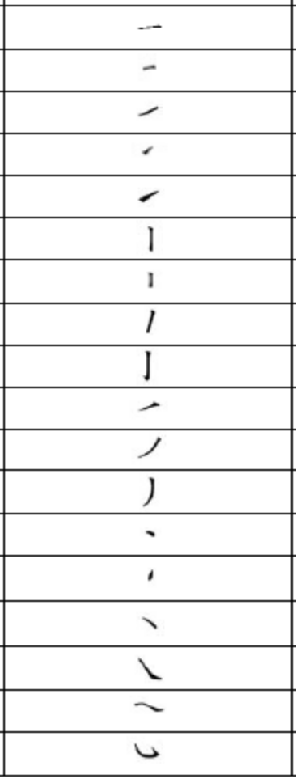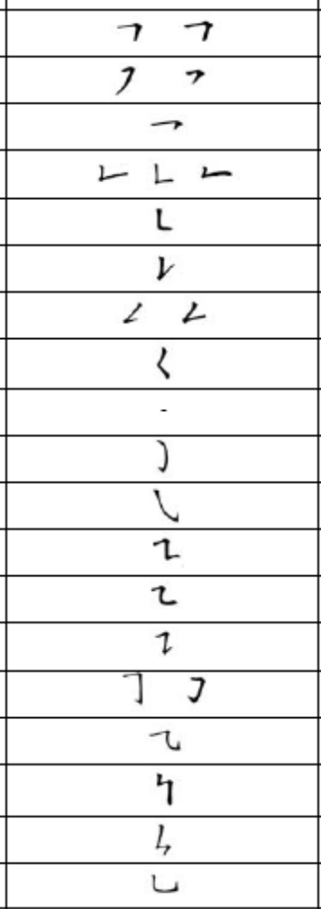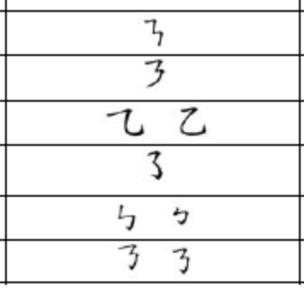
Figure 1 Chinse character stroke list (Education)

What we do in this project is that for each stroke, we select a set of characters which contains that stroke, then we pick up the only one character which is more frequently used than others. Finally, we got the following data set: 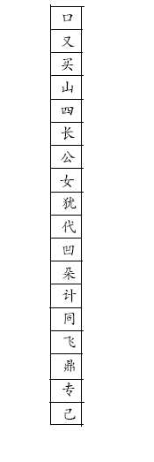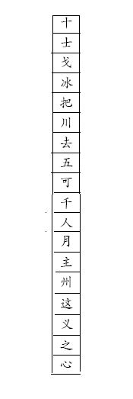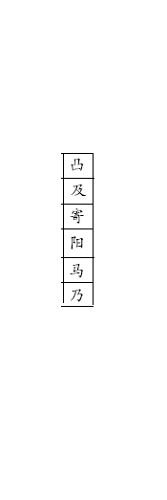
Figure 2 Data collection

Data organization
After getting the data collection, we need work out how to organize the data. In this project, we will create a data framework according to the role of the data play.

At the top of the data framework, all the data will be categorised into two types – training data and recognition data. We need allocate some of the data in the data collection as the training data, and the rest as the recognition data. As mentioned before, for each Chinese character, we let user write ten times in the writing pad and store in the central repository. We use the first eight times as the training data and the rest as the recognition data.

In terms of the training data, it can be further categorised into three types – Raw data, Initial Data and Optimised Data. Raw data is the data we get directly from the writing pad without any process; after pre-processing or initialising the raw data, we get the initial data; after optimising the initial data, we end up with the optimised data. Further details about these three types of data and processing, please refer to the following section. Under Raw Data directory, we classify all the raw data by character, and store the all the raw data file which represent the same Chinese character within one directory. Following the same pattern, all the feature data (initialised data) will be categorised by character as well. There are two text file are associated with each character. One of the text file contains the distribution probability of features in each character. The other text file contains the transition probability of states in each character. With regards to distribution and transition probability, please refer to the following sections. “Optimised Data” folder use exactly same structure with “Initial Data” folder. It contains a sequence of folders categorised by character and text files which are associated with each character. However the only difference between “Initial Data” folder and “Optimised Data” folder is the content within each character folder. In the character folders under “Initial Data”, the text files contain the feature data. But in the character folders under “Optimised Data”, the text files contain the Viterbi sequence data.

In terms of recognition data, it can be further categorised into three types as well – Raw data, Feature data and Result data. The “Raw data” folder shares the exactly same structure with “Raw data” folder under training data. The “Feature data” folder is similar to the “Initial data” folder under training data except that “Feature data” folder doesn’t contain the distribution and transition probability files. The “Result” folder contains all the recognition results.

The picture below shows the data framework.
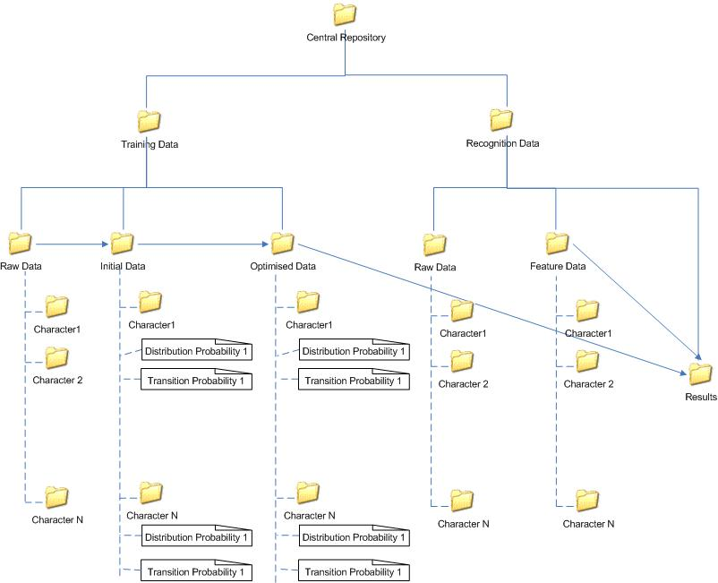
Figure 3 Data framework

Data format
So far we have discussed the overall data framework structure. Now we get into more details about the data files. There are two options for us to store the data files, text and binary. In terms of the efficiency, binary should be a better choice. In this project, however, we focus more on the feasibility and the accuracy of the mathematic model and algorithm, furthermore, for easy diagnostic purpose, we used text format for all the data files. To improve the efficiency of the recognition system, binary format can be used in the future work.

Raw data file
We follow the order we discuss the folders in previous section. We start with “Raw data” folder in the “Training data” folder. In each Character folder, there are a number of files which represent the same character. Those files contain the raw data which means the data directly retrieved from the writing pad without any processing. From the system point of view, the characters which are drawn by the users are just a sequence of dots in the coordinate and nothing more than that. So when we store those dots for a character, we should see a sequence of X, Y coordinates. The separator should be used between X, Y coordinates, and we use “,” in the raw data files. While retrieving the sequence of the dots which represent the characters, we need take some action to clearly identify the border between strokes. We use tag mechanism to do so. All the dots which belong to the same stroke will be stored between tag “<s>” and “</s>”. A screen shot of two-stroke character raw data file can be found below:
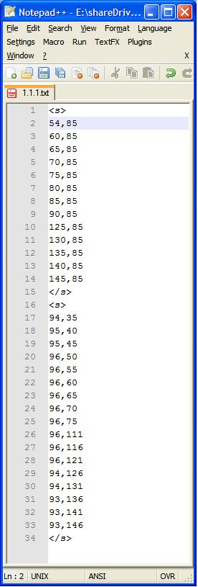
Figure 4 Raw data text file

Feature data file
In essential, Feature data files are the raw data files after feature analysis process. There will be one to one mapping between raw data files and feature files. Furthermore, during the feature analysis process, information loss should never occur, so the feature data file contains the exactly same number of rows as the raw data file. By comparing the two screen shots (one for raw data from previous section and one for feature data below), we can see there 34 rows in raw data file, and 4 of them are tags. So the corresponding feature file contains 30 rows. It should be noted that the feature doesn’t employ the tag mechanism, since the recognition system use different method to handle these types of files. To segment the strokes in the character in the feature file, we use “add/minus” mechanism. We already know the number appear in the feature data files are always between “0” and “15”, so we need find some particular number, and after adding that particular number to the original value, the original value can be significant change and is out of the normal range. The particular number we pick up is “16”. For the first value of each stroke, we add number “16” to it, and for the last value of each stroke, we minus “16” to it. Every time the system meets a number larger than 15 or less than 0, it will notice that is the beginning or end of a stroke.
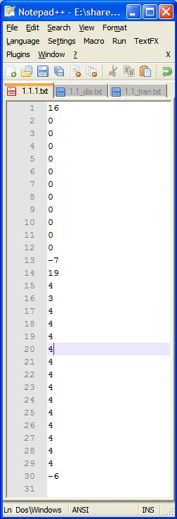
Figure 5 Feature data file

Distribution probability file
We mentioned in the previous section, there can be sixteen different numbers in the feature data files (don’t include the heading and ending process). Actually, those sixteen numbers represent the sixteen possible statuses of features. Every feature is in one of the sixteen statuses in each state, and the percentage of particular status occupy in the state is called the distribution probability of that status. The distribution probability files contains a list of sections, and each section consists of sixteens rows which represent the sixteen different status of a state. Like the raw data and feature data files, we still need locate the border of the states, but no additional mechanism is required to do so. Since each state section always occupy sixteen rows in the file, we can locate the border by counting the number of rows. One thing we should notice is the summary of each state section should always equal one.

Transition probability file
Similar to the distribution file, transition probability contains a list of probabilities as well. The transition probability describes the probability of one state jumping to another. Since different characters may contain different number of states, we can not use the “counting row” method to locate the border of states. The probability is always between 0 and 1, so we can use the mechanism used in raw and feature data file. However, in some middle stages of the recognition process, we want to keep the summary of probability equal one. Furthermore, each section in the transition probability files represents one row in a 2D array. So instead of using the “add/minus” mechanism, we manually add some tag between sections. The tag we used is “new row”. The screen shot below shows part of the transition probability file.
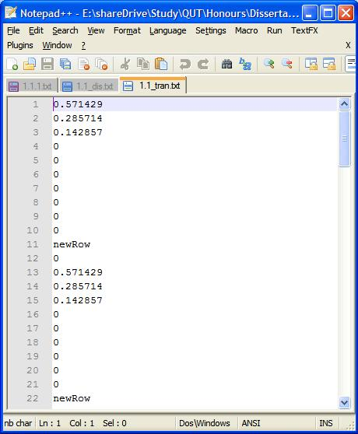
Figure 6 part of a transition probability file

Result file
The result file contains the recognition result of a character. At the top of the file, it shows information about input character for recognition, and a sequence of match patterns are listed below in descending order by the similarity. An assistant ranking number mechanism is used to make the result easier to read. The screen shot below shows the recognition result of character with ID 1.2.
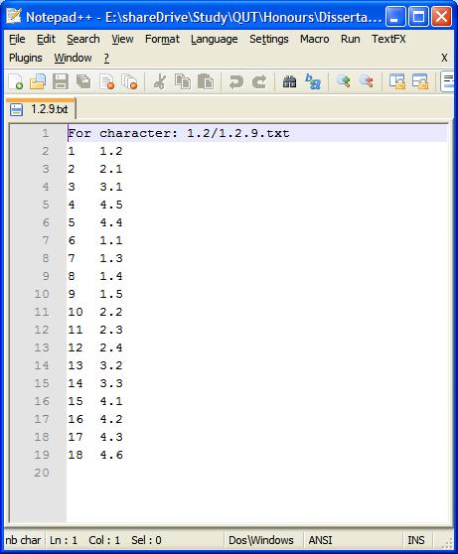
Figure 7 Result file

Initial raw data collecting and processing
As discussed in the writing pad section, every time the GDK_POINTER_MOTION_HINT_MASK is called, it will record the current position of the cursor in the writing pad, and until the user issue a signal to the writing pad to indicate the end of input, the writing pad will output the list of position to a text file. The interval between GDK_POINTER_MOTION_HINT_MASK events is only 0.05 second, as the result, we could end up with a huge number of cursor positions. If we use these data without some necessary processing, the overall efficiency of the recognition system could be significantly decreased. The GDK_POINTER_MOTION_HINT_MASK interval is fixed, and we can not do much about it. But we can do is periodically pick up some cursor positions rather than pick up all. There are two easy implementations solution for this problem. One is setting up some time frame, for example double or triples the GDK_POINTER_MOTION_HINT_MASK interval. Another one is setting up the distance between two cursor positions. The former one may introduce new problem to the data collection. For example, if the user input first half part of the stroke quite slow, and second half part of the stroke quite fast. Most of the data will be representing the first half of the stroke, the first part will become the dominating part and the whole stroke is not balanced. In this project, we take the latter approach, and set the distance interval to 5 pixels. The number of distance interval can be slightly adjusted, but can not be less than 3. The reason for this will be given in “Feature analysis” section.

Feature analysis
HMM is a pure mathematic model, but handwriting is more on the Graphic User Interface side. We need have some mechanism sitting between them, and let them be able to talk to each other. As mentioned in the literature review, HMM need five essential elements. To apply the HMM to the real world research problem, the elements “state” and “observation” should be firstly resolved. We need decided what the states and observation should be in the model correspond to, and then deciding how many states should be in the model.

Character decomposition
In this project, we use the single Chinese character as the training and recognition unit. Each unit consists of several sections which correspond to the strokes in that character. The section is the container of the “states”, and each section contains a fix number of states. In other word, we used a fix number of states to represent a stroke. Now, we go back to section 3.2.1, by observing the Figure “Chinse character stroke list”, we can see the most complicated stroke of Chinese character is “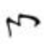”, which consist of five segmentations. What this mean is that we need at least use five states in a stroke to cope with all the possible occurrences. Theoretically, the more segmentations (or states) the strokes have, the more accurate the recognition results should be, but the efficiency of the recognition system will go down as it need process more states in each stroke. In this project, we focus on the feasibility of HMM and reasonable accuracy. So we start with five states in each stroke. To make the definition more clearly, we use a two-stroke character as the example to demonstrate. The character “人” can be represented using the following state sequence: S₀, S₁, S₂, S₃, S₄, S₅, S₆, S₇, S₈, S₉.

State decomposition
Up to this stage, we have decomposed the Chinese character into a sequence of stages, but we haven’t completely finished the mapping between the Chinese character and the raw data. Furthermore, we haven’t decided what the observation of HMM correspond to yet. What we are going to do here is to pick up a pair of cursor position data from a raw data file. By putting these two position data in the coordinate, they can determine an angle. We divide the entire coordinate into sixteen equal parts, and assign each part a number starting from 0 and ending with 15. Then according to the angle, we use the correspond number to replace the position data, and output to a text file which is called feature file. We repeat the procedure to all the raw position data, and finally we will get a collection of feature data which correspond to the original raw data files. The picture below shows the sixteen segmentation of the coordinate.
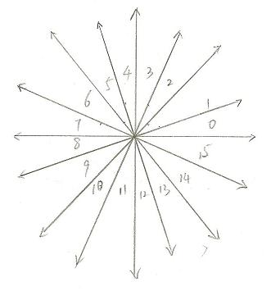
Figure 8 Coordinate segmentation

After getting the feature data, the observation problem has been solved implicitly. Basically, we can use the feature data as the observation in HMM. The last thing we need to do is to create the relation between the states and features. We let the state be the container of features, and store the features by allocating them according to their feature number. From the software engineer point of view, the state contains an array with the size 16. Every item in the array contains the number of same type of features. For example, a state which contains 35 features may have the following structures:
0 | 1 | 2 | 3 | 4 | 5 | 6 | 7 | 8 | 9 | 10 | 11 | 12 | 13 | 14 | 15
0 | 2 | 3 | 1 | 5 | 0 | 4 | 3 | 1 | 1 | 1 | 1 | 2 | 5 | 2 | 4
Figure 9 Feature distribution in a state
This state does not contain feature with number “0” and “5”; contains only one feature for feature with number “3”, “8”, “9”, “10” and “11”; contains two features for feature with number “1”, “12” and “14”; contains three features for feature with number “2” and “7”; contains four features for feature with number “6” and “15”; contains five features with number “4” and “13”.

By now, the entire GUI character has been transformed into a sequence of number which can be coped by HMM.

Training state initialisation
In the feature analysis phase, we have already figured out two elements of HMM, the “state” and the “observation”. In order to apply the HMM to our recognition system, we need figure out the rest three elements before we move on. In this project, we will deliver some software prototype rather than a perfect recognition system. So some assumptions need to be made at the very beginning. Firstly, we assume the users know the correct order to write the strokes in Chinese characters. Secondly, we assume the users know the correct way to write the Chinese strokes. Every Chinese character has a standard way to draw, and we made the assumption that all the users are aware of the standard. What it means is that for a character, we always start at the same stroke and use the same way to draw that stroke. In terms of the initial state distribution π, it is certain we always start at state S₀.

Observation segmentation
HMM is always associated with statistic methodology. In our project, we have a number of training examples for each character. Since all the raw data files which represent the same character are grouped together (see Data organization section), we can easily process them group by group. In each raw data or feature file, there is no separator between the states. One of the goal we want to achieve by using Viterbi algorithm (see section “Customized Viterbi Algorithm” is to find out the proper border between the states, but before we do that, we need roughly give a border to the states. The approach we use is to try to equally divide the list of feature observation in each stroke in each feature file into a fix number (the number is 5 in our project). For example, if there are 16 feature observations in a stroke, we will end up with 3, 3, 3, 3 and 4. What this means is that the first three feature observation belong to state one; the second three feature observation belong to state two, and so on.

Feature distribution
After roughly divide the strokes into five states, now we can do something on states. We go through each file in the group and count the accumulated value of each feature in each stroke. For example, if we have two training example files one and two, for state X, after the process, we will end up with the last table shown below.
State X in file one:
0 | 1 | 2 | 3 | 4 | 5 | 6 | 7 | 8 | 9 | 10 | 11 | 12 | 13 | 14 | 15
0 | 2 | 3 | 1 | 5 | 0 | 4 | 3 | 1 | 1 | 1 | 1 | 2 | 5 | 2 | 4
State X in file two:
0 | 1 | 2 | 3 | 4 | 5 | 6 | 7 | 8 | 9 | 10 | 11 | 12 | 13 | 14 | 15
1 | 1 | 4 | 0 | 3 | 2 | 3 | 3 | 2 | 0 | 0 | 3 | 6 | 4 | 2 | 2
Static State X value:
0 | 1 | 2 | 3 | 4 | 5 | 6 | 7 | 8 | 9 | 10 | 11 | 12 | 13 | 14 | 15
1 | 3 | 7 | 1 | 8 | 2 | 7 | 6 | 3 | 1 | 1 | 4 | 8 | 9 | 4 | 6

State Transition

Training state optimisation

Customised Viterbi algorithm
Border handling

Observation segmentation

Feature distribution
Please refer to section “Feature distribution” in “Training state initialisation”.

State Transition
Please refer to section “State Transition” in “Training state initialisation”.

Character recognition

Chapter Four: Experiment and Results

Data Sets Selection

Evaluation Criteria

Scalability (cover the extend data sets)

Result Evaluation

Chapter Five: Conclusion and Future work

Findings and Analysis

Improvements

Writing Pad XInput support

References

